# Q1

Write a query to display the last name and hire date of any employee in the same

department as Zlotkey. Exclude Zlotkey.

# Query

SELECT last_name, hire_date

FROM hr.employees

WHERE last_name != 'Zlotkey'

AND department_id = (

    SELECT department_id

    FROM hr.employees

    WHERE last_name = 'Zlotkey'

);

# Output

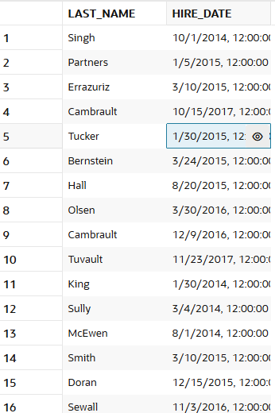 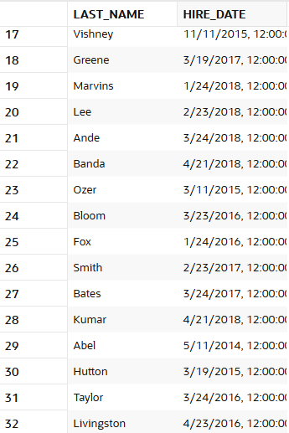



# Q2

Create a query to display the employee numbers and last names of all employees who earn

more than the average salary. Sort the results in ascending order of salary.

# Query

SELECT employee_id, last_name, salary

FROM hr.employees

WHERE salary > (

    SELECT AVG(salary)

    FROM hr.employees

)

ORDER BY salary ASC;

# Output

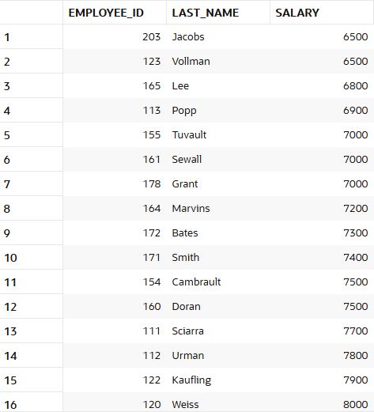 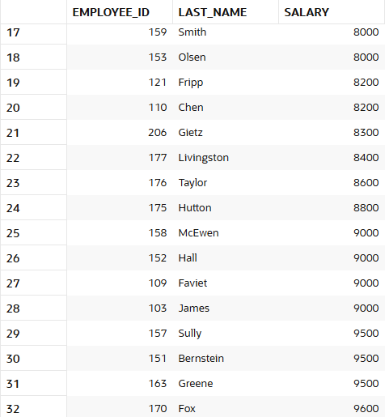 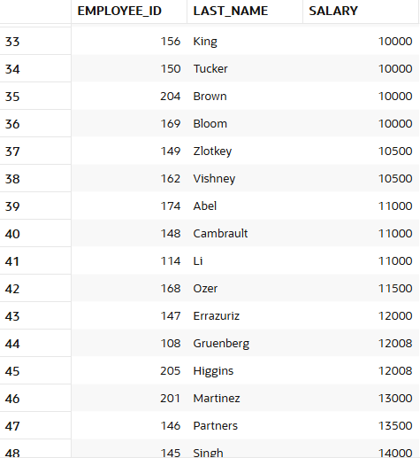

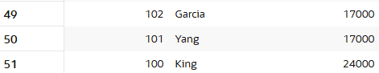

# Q3

Write a query that displays the employee numbers and last names of all employees who

work in a department with any employee whose last name contains an ‘e’.

# Query

SELECT employee_id, last_name

FROM hr.employees

WHERE department_id IN (

    SELECT DISTINCT department_id

    FROM hr.employees

    WHERE last_name LIKE '%e%');

# Output

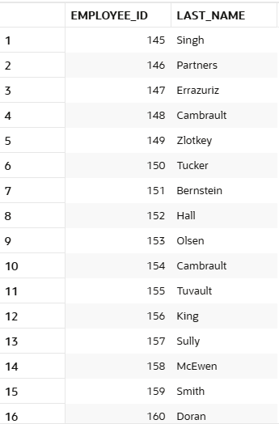 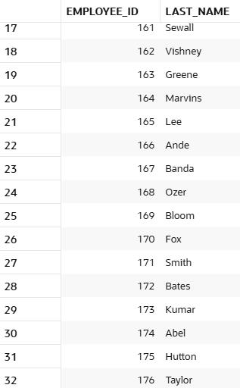 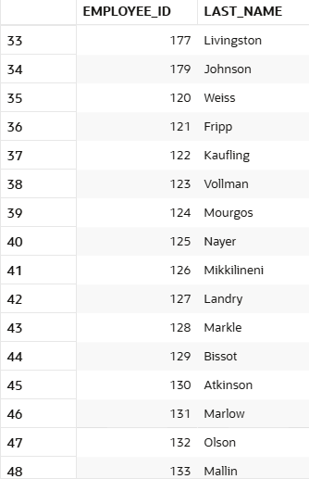 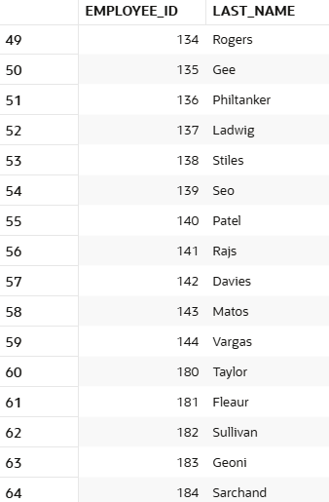 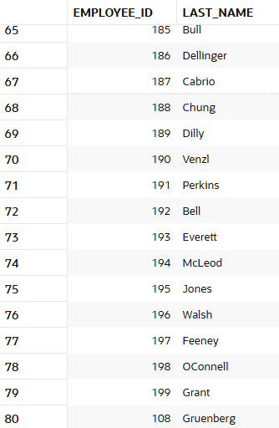 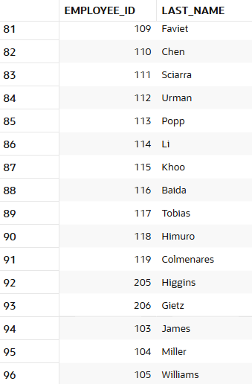

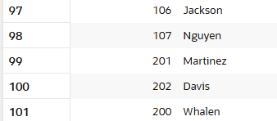

# Q5

Display the last name, department number, and job ID of all employees whose department

location ID is 1700.

# Query

SELECT e.last_name, e.department_id, e.job_id

FROM hr.employees e

JOIN hr.departments d ON e.department_id = d.department_id

JOIN hr.locations l ON d.location_id = l.location_id

WHERE l.location_id = 1700;

# Output

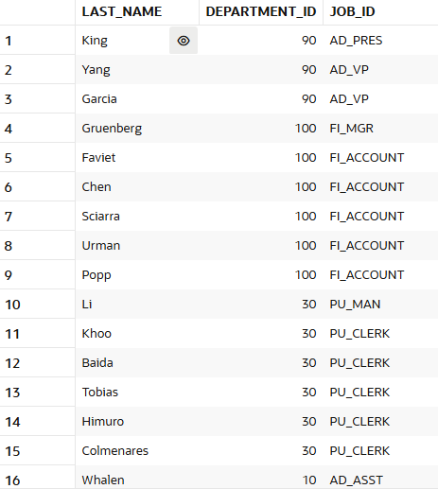 

# Q5

Display the last name and salary of every employee who does not report to King.

# Query

SELECT last_name, salary

FROM hr.employees

WHERE manager_id NOT IN (

    SELECT employee_id

    FROM hr.employees

    WHERE last_name = 'King'

);

# Output

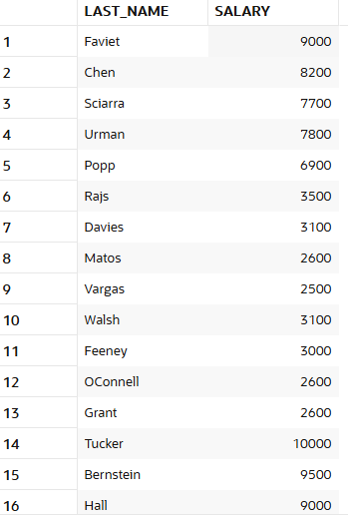 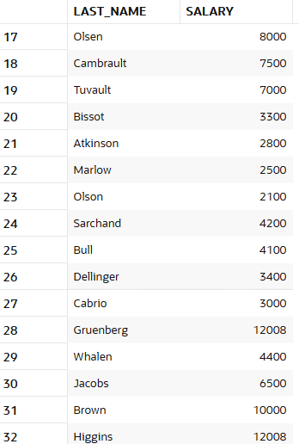 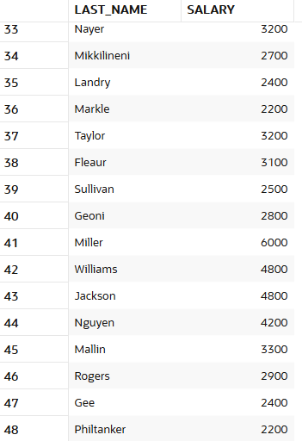

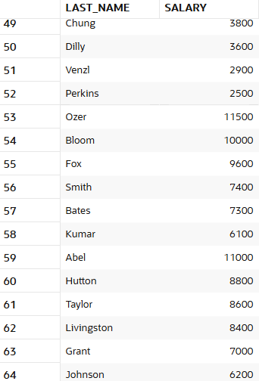 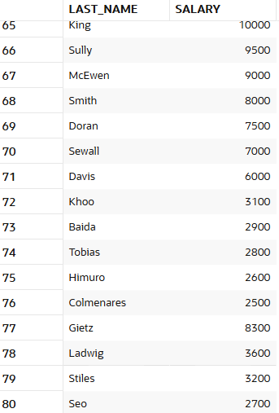 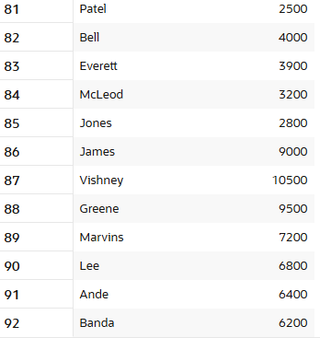

# Leetcode

[**185. Department Top Three Salaries**](https://leetcode.com/problems/department-top-three-salaries/)

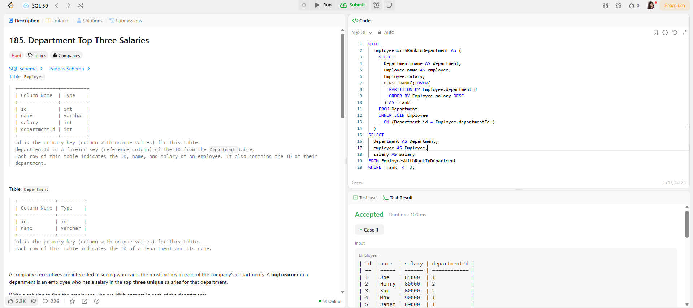

[**585. Investments in 2016**](https://leetcode.com/problems/investments-in-2016/)

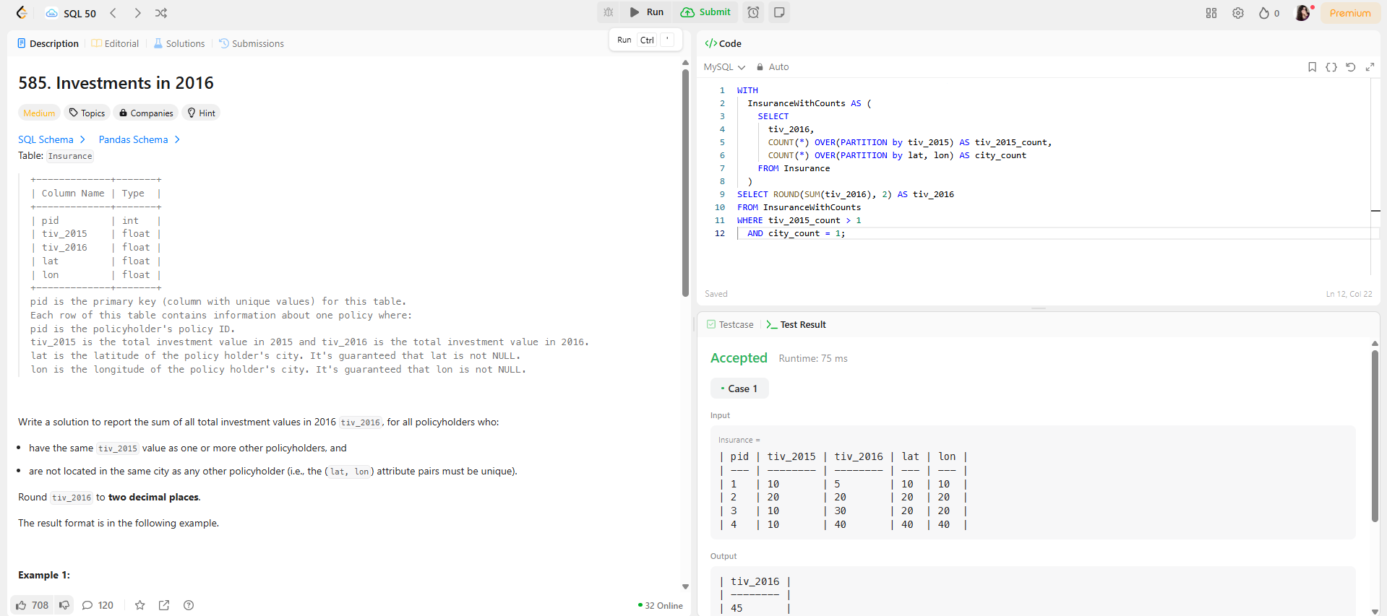

[**602. Friend Requests II: Who Has the Most Friends**](https://leetcode.com/problems/friend-requests-ii-who-has-the-most-friends/)

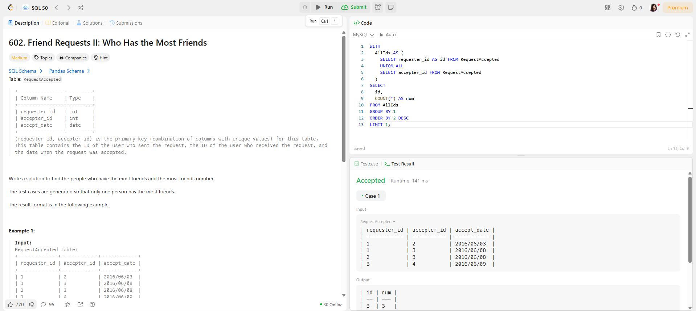

[**1321. Restaurant Growth**](https://leetcode.com/problems/restaurant-growth/) 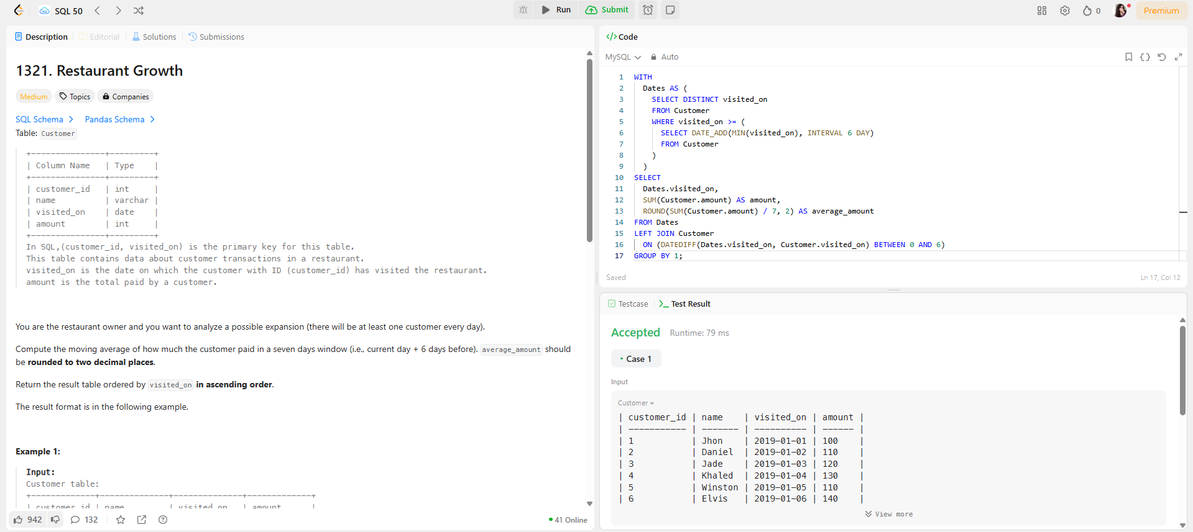

[**1341. Movie Rating**](https://leetcode.com/problems/movie-rating/) 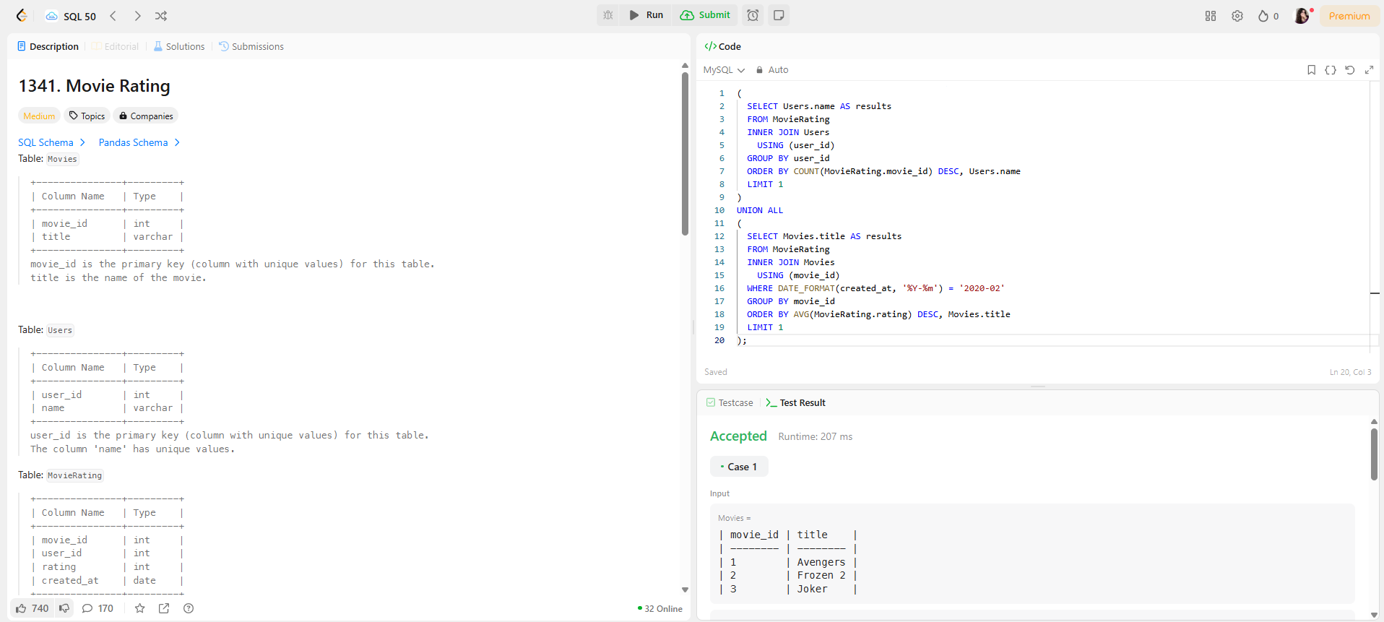

[**626. Exchange Seats**](https://leetcode.com/problems/exchange-seats/) 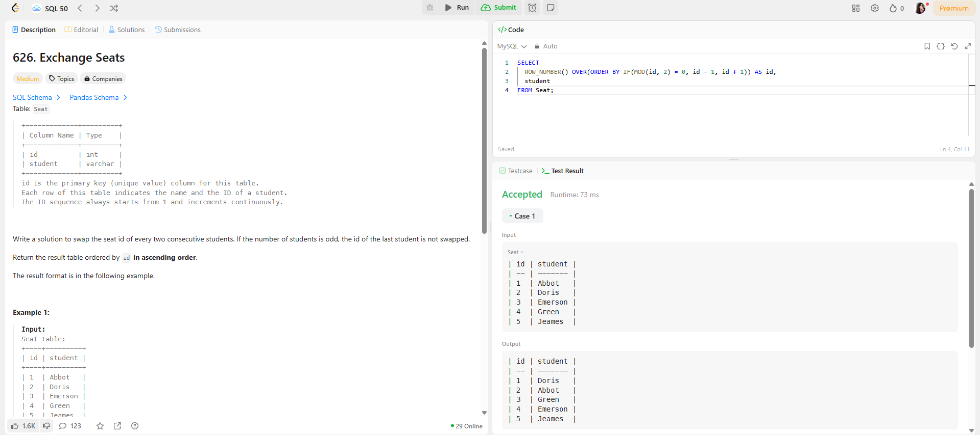 [**1978. Employees Whose Manager Left the Company**](https://leetcode.com/problems/employees-whose-manager-left-the-company/) 